**SYD Airbnb Analysis SYSTEM USER MANUAL**

**Student Names:**

* **Quoc Nam Ngo s5239492**
* **Tszhoi Leung S5245510**
* **Md Tanvir Mannan s5202602**

***This is a short and simple guide for users to follow when using the new system for case reports and case analysis. Here you will find illustrations and instructions on how to retrieve the data you need. Please look at the illustrations and this manual before continuing to use this system.***

## **Installation Guide**

**Before running this system, please ensure you have installed the following program and the libraries that come with it:**

* **Install PyCharm (x64 bit for this system)**
* **Run pyCharm and open a new project.**
* **Click on file option in the top left-hand corner and select settings.**
* **Scroll down to the projects option and under that, select python interpreter.**
* **This option will now allow you add by clicking on the + sign in the left-hand corner of the interpreter page.**
* **Click on the + sign and search for the libraries in the Figure 15**
* **For each library ensure you install the full package**
* **Please refer to the figures 16 to 19 for the steps in this installation guide.**
* **Once you have completed these steps, run the main.py file to get to your user interface.**
* **Please go through the instructions below which show the steps to getting the system to perform the tasks required.**

1. **Login**

to access and use the system first you need to create or login to an account

* **Click “Login” button to login to the system**
* **After clicked on “Login” button – the Login/Register board will appear**

* **The User ID and Password fields are used for both way for register or login function**
* **If you are new user and you need to register for an account:**
  + **You will be asked to full fill the require information**
  + **Enter all require fields (User ID and Password)**
  + **Ticked the register square **
  + **Then click on the blue button to register Graphical user interface, text, application

    Description automatically generated**
  + **The display board will appear after that to announce that you are successfully registered or not**

* **If you already have an account, you do not need to tick the register squire and just full fill your information (user id and password) and then click login button**
* **If you enter the correct information that you registered account before you will be led to the menu page of app after that, otherwise the warning board will appear to announce that your entered information is invalid**

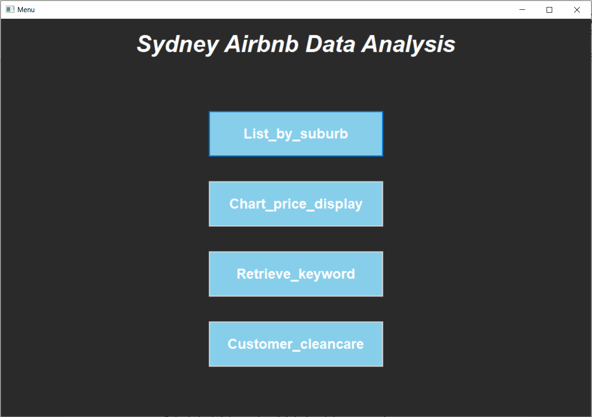

1. **TO VIEW INFORMATION OF SYD AIRBNB LIST BY SUBURB**

* **Select the List_by_suburb button at the top of the menu.**
* **Enter a specific suburb name in the “Suburb Name” field**
* **Select start date, and end date for data you need.**
* **Click okay to search and display.**
* **You may use the snipping tool to take a screenshot of the data you need.**
* **You may use the scroll bars on the x and y axis to move the data around to see what you need to view.**
* **Click back to menu once you have finished.**

Figure

Figure

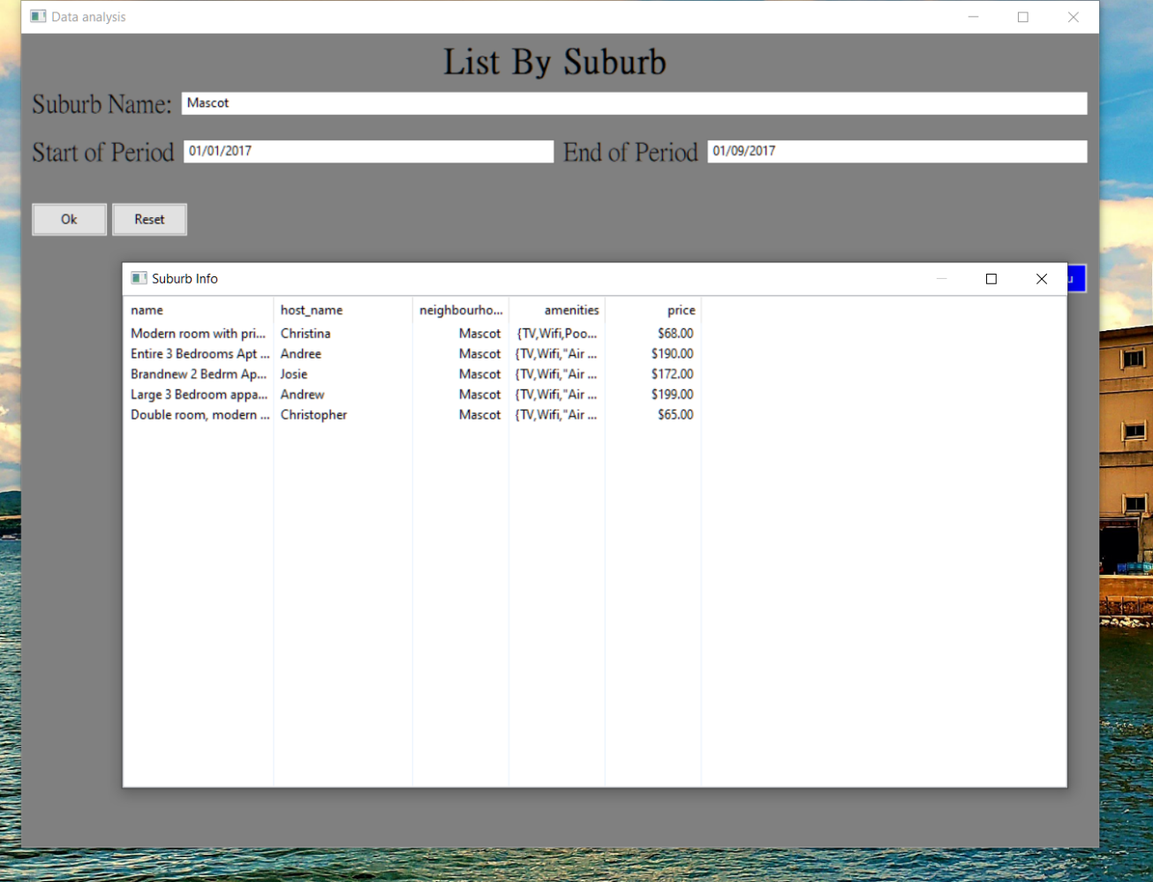

Figure

1. **TO VIEW Price of the property distributed over time with visualisation**

* **Select the Chart_price_display option at second button of menu from the top.**
* **Select start date, and end date for data you need.**
* **Click okay to display.**
* **You may use the snipping tool to take a screenshot of the data you need.**
* **Click back to menu once you have finished.**

Figure

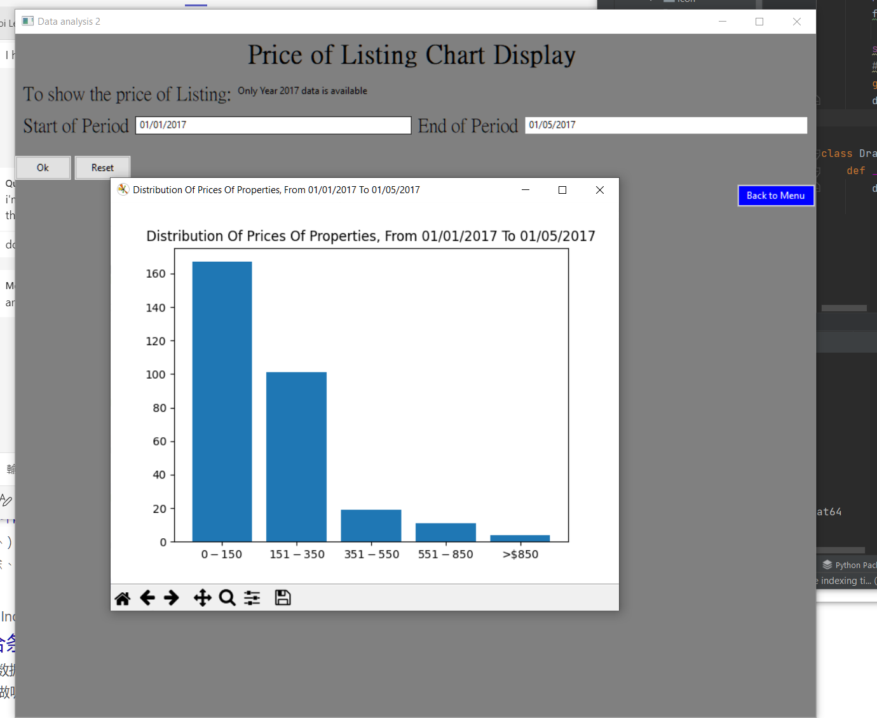

Figure

1. **TO SEARCH INFORMATION BY KEYWORD**

* **Select the Retrieve_keyword button at the second bottom in the menu page.**
* **In the “Amenities Keyword” field, input the specific keyword you aim to looking for the information**
* **Select start date, and end date for data you need.**
* **Click okay to display.**
* **You may use the snipping tool to take a screenshot in the data you need.**
* **Click back to home once you have finished.**

Figure

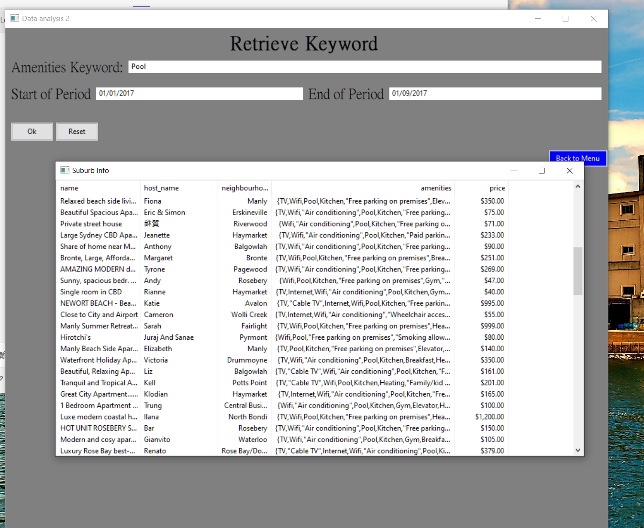

Figure

1. **TO View most common or Add keyword commnet**

* **Select the Customer_clearance button at the bottom in the menu page.**
* **Add a specific keyword in the “Add Keyword” field**
* **Click okay to display.**
* **You may use the snipping tool to take a screenshot of the data you need.**
* **Click back to home once you have finished.**

Figure

Figure

Figure

## **2.0 Installation Guide Figures**

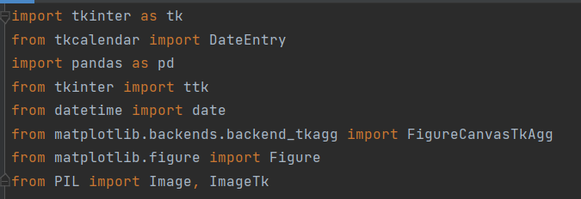

Figure

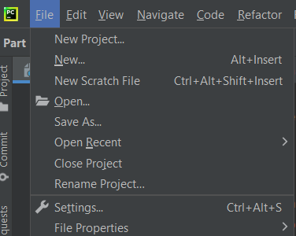

Figure

Figure

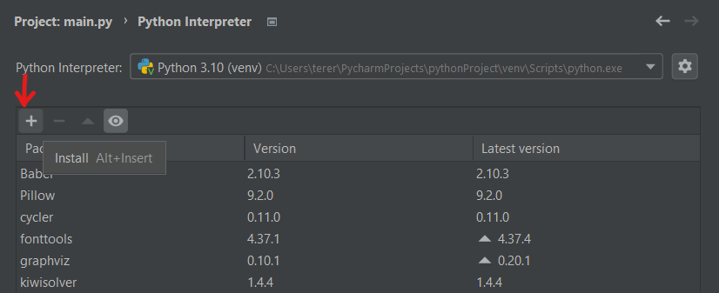

Figure

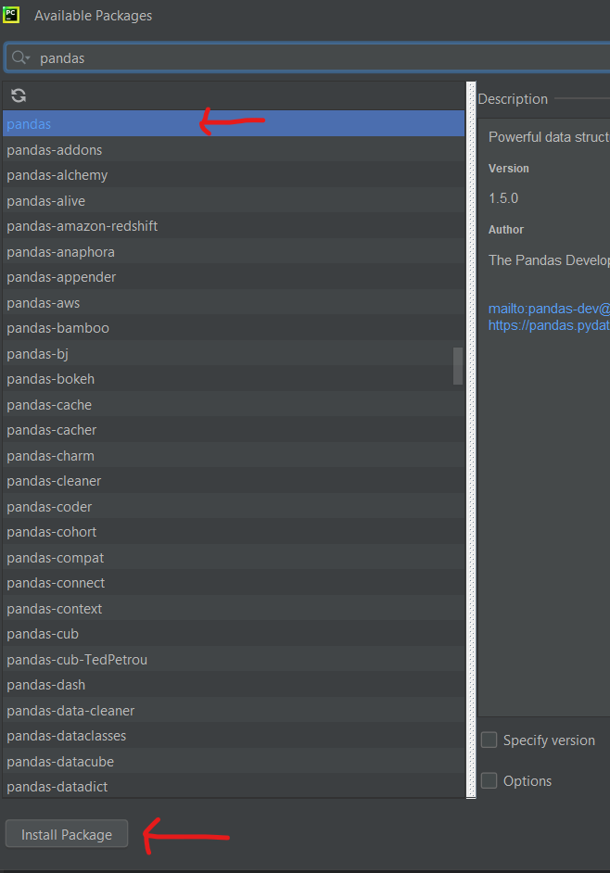

Figure

***For any technical support kindly email your IT manager, and they be able to assist with any issues. For all other vendor related enquiries, please feel free to contact us.***